**The Egyptian E-Learning University (EELU)**

**Faculty of Information Technology**

**Graduation Project**

**2023-2024**

**Job Fit Analyzer**

**Supervisors**

Prof. Dr. Khaled T. Wassif

Eng. Engy Emad Beshara Salib

**Team Members**

Mohamed Khaled Mohamed Moghraby

Ahmed Mohamed Tawab

Makarious Ayman Shafek

Mohamed Montser Mohamed

Sandy Nashaat Wadea

Mohammad Atef Nasr Labib

Ziad Mamdouh Ahmed

**DECLARATION**

We hereby certify that this report, which I now submit for assessment on the program of study leading to the award of Bachelor of Science in Information Technology Bachelor, is all my own work and contains no plagiarism. By submitting this report, I agree to the following terms:

*Any text, diagrams or other material copied from other sources*

*(including, but not limited to, books, journals, and the internet)*

*have been clearly acknowledged and cited followed by the reference*

*number used; either in the text or in a footnote/endnote. The details*

*of the used references that are listed at the end of the report are*

*confirming to the referencing style dictated by the final year*

*project template and are, to my knowledge, accurate and complete.*

I have read the sections on referencing and plagiarism in the final year project template. I understand that plagiarism can lead to a reduced or fail grade, in serious cases, for the Graduation Project course.

Student Name: Mohamed Khaled Moghraby Student Name: Ahmed Mohamed Tawab

ID: 2000912 ID: 2001750

Signed: Signed:

Date: 24/6/2024 Date: 24/6/2024

Student Name: Sandy Nashaat Wadea Student Name: Makarious Ayman Shafek

ID: 2001834 ID: 2001911

Signed: Signed:

Date: 24/6/2024 Date: 24/6/2024

Student Name: Mohamed Montser Mohamed Student Name: Ziad Mamdouh Ahmed

ID: 2001861 ID: 2000251

Signed: Signed:

Date: 24/6/2024 Date: 24/6/2024

Student Name: Mohammad Atef Nasr Labib

ID: 2000643

Signed:

Date: 24/6/2024

**ACKNOWLEDGMENT**

We have taken efforts in this project. However, it would not have been possible without the kind support and help of many individuals and organizations. I would like to extend my sincere thanks to all of them.

We highly indebted to (Doctor Khaled Wasif) for the guidance and constant supervision as well as for providing necessary information regarding the project & also for the support in completing the project.

Also We indebted to (Eng. Engy Emad) for the guidance and constant supervision as well as for providing necessary information regarding the project & also for the support in completing the project.

I would like to express my gratitude to wards my parents & member of (The Egyptian E-Learning University) for the kind co-operation and encouragement which help us in completion of this project.

I would like to express my special gratitude and thanks to supervisor`s persons for giving me such attention and time.

My thanks and appreciations also go to my colleagues in developing the project and people who have willingly help me out with their abilities.

Table of Contents

**Table of Figures** 10

**Abstract** 11

**Objective** 12

**System Requirements** 14

**Functional Requirements** 14

**Non-Functional Requirements** 16

**Similar Systems** 17

**Local System** 17

**International System** 18

**System Architecture** 19

**System Overview** 19

**Architecture diagram** 20

**Use Case Diagram** 21

**Sequence Diagram** 22

**Database Design** 23

**Server-side Architecture** 26

Main Entities in Prisma 27

**Client-side Architecture** 30

**AJAX** 30

**Fetching data from the server** 30

**React** 31

**Benefits of choosing React Technology** 32

**Next.js** 32

**Benefits of choosing Next.js Technology:** 33

**Material UI (MUI)** 33

**API Integration in React** 33

**Authentication** 34

**NextJs Authentication** 36

**Technology Stack** 37

**AI Integration** 39

**Key Highlights** 39

**Machine Learning Algorithms** 40

**Supervised Learning**40

**Unsupervised Learning** 42

**Reinforcement Learning** 43

**Types of Recommendations systems** 44

**Content-Based Recommendations** 44

**Collaborative Filtering** 45

**Hybrid Recommendations** 46

**Dataset** 48

**AI Endpoint** 56

**Flask Overview** 56

**UI/UX Design** 58

**UI Design** 58

**UX Design** 58

**Preview** 59

**Conclusion** 66

**Future Work** 67

**Implementation** 67

**References** 68

**Appendix** 69

# **Table of Figures**

Figure 1 Wuzzuf.com 11

Figure 2 Indeed.com 12

Figure 3 System Design 14

Figure 4 Usecase Diagram 15

Figure 5 Sequence Diagram 16

Figure 6 Database Schema Diagram 19

Figure 7 Server-side Rendering 20

Figure 8 User Model 21

Figure 9 Account Model 21

Figure 10 Job Model 22

Figure 11 Application & Company Models 22

Figure 12 Profile 23

Figure 13 Experience & Education 23

Figure 14 Data fetching 24

Figure 15 React Diagram (1) 25

Figure 16 React Diagram (2) 26

Figure 17 JWT Auth 29

Figure 18 Prisma Rest 32

Figure 19 Second Dataset 44

Figure 20 Accuracy Score Third Dataset 45

Figure 21 Third Dataset 45

Figure 22 Current Dataset 46

Figure 23 Accuracy Score Current Dataset 48

Figure 24 Updated Accuracy Scores Current Dataset 48

Figure 25 Output Current Dataset 49

Figure 26 Home page 53

Figure 27 Sign up page 54

Figure 28 Log in Page 54

Figure 29 Profile page 55

Figure 30 Jobs Page 57

Figure 31 Admin Dashboard 58

Figure 32 Recruiter Dashboard 59

Figure 33 Application page 59

# **Abstract**

This project addresses the current complexity and inefficiency of job matching in today's labour market, leading to job dissatisfaction, high turnover, and resource-intensive hiring processes for both candidates and employers.

Our solution is the development of a Job Fit Analyzer, powered by AI models and advanced software. This innovative solution aims to streamline and optimize the job matching process by utilizing state-of-the-art artificial intelligence techniques.

The Job Fit Analyzer is designed as a web application, functioning as a comprehensive job portal.

This web-based platform will not only enhance the efficiency of job matching but also provide a user-friendly experience for both job seekers and employers, revolutionizing the way individuals find suitable employment opportunities and organizations identify qualified candidates.

# **Objective**

The overarching objective of this project is to conceptualize, design, and implement an advanced job portal system that transcends traditional job search platforms. Our aim is to create a dynamic ecosystem where job seekers and recruiters seamlessly converge, fostering a symbiotic relationship.

For job seekers, the project endeavors to deliver a user-friendly interface empowering them to effortlessly explore, apply for, and manage job opportunities. The system's sophistication lies in its ability to provide personalized job recommendations through an innovative AI-powered engine, ensuring that job seekers encounter opportunities tailored to their skills and preferences.

Recruiters, on the other hand, will benefit from a robust set of tools that enable them to efficiently post, manage, and evaluate job listings. The system seeks to streamline the recruitment process, offering recruiters an intuitive platform to engage with potential candidates effectively.

Throughout the project lifecycle, a key focus will be on implementing cutting-edge technologies and methodologies. This includes the incorporation of a notification system to keep users informed of relevant updates and events. Additionally, we aspire to enhance caching mechanisms using Redis, optimizing the system's performance and responsiveness.

By the conclusion of this project, our vision is to deliver a comprehensive job portal solution characterized by its security, scalability, and user-centric design. We anticipate that the implemented features and innovations will not only meet but exceed the expectations of both job seekers and recruiters, elevating the overall experience within the realm of job searching and hiring.

# **System Requirements**

## **Functional Requirements**

**User Types**

**Admin:**

* + - Full CRUD operations on Applications, Users, Jobs, etc.

**Job Seeker:**

* + - Apply for a job.
    - View/Update Profile.
    - Create and edit profiles with relevant information.
    - View Applications.
    - Upload CV/Resume.
    - Verify Email and Phone number.

**Recruiter:**

* + - Post a Job.
    - Manage job status and details.
    - View Applicants for the job.
    - Download applicant’s CV.
    - Accept or reject an application.

**Common Login Functionality for All Users**

1. Validation during login.
2. Display appropriate error messages.

**Job Search and Filters**

Implement job search functionality with filters for:

* + Location.
  + Industry.
  + Job type.
  + And more.

**AI-Powered Job Recommendation and Search**

* The AI system should:
  + Analyze user preferences.
  + Evaluate job listings.
  + Provide personalized job recommendations.

**Feedback and Ratings**

* Allow both Recruiters and Job Seekers to:
  + Provide feedback.
  + Rate the recruitment process.

## **Non-Functional Requirements**

**Performance:**

**Response Time:**

Ensure quick response times for actions like job searches and profile updates.

**Scalability:**

Make sure the system can handle more users as needed.

**Security:**

**Authentication:**

Keep user logins secure using standard protocols.

**Authorization:**

Allow users access based on their roles.

**Data Encryption:**

Protect sensitive information with encryption.

**Usability:**

**User Interface Consistency:**

Maintain a consistent and user-friendly interface.

**Accessibility:**

Ensure the system is accessible to users with disabilities.

**Integration:**

**Third-Party Integration:**

Seamlessly connect with external services.

**Compatibility:**

Ensure compatibility with popular browsers and operating systems.

# **Similar Systems**

## **Local System**

**Wuzzuf.com (An Egyptian Job Portal Website)**

*Figure 1 Wuzzuf*

**Advantages:**

* + User friendly UI
  + Comprehensive Job Listings
  + Employer Tools
  + Local Insights
* **Disadvantages:**
  + Too reliant on skills
  + Security and Data Protection
  + Language Barrier – *The website is supposed to be in Arabic,but it displays in English.*
  + Machine Learning Integration

## **International System**

**Indeed.com**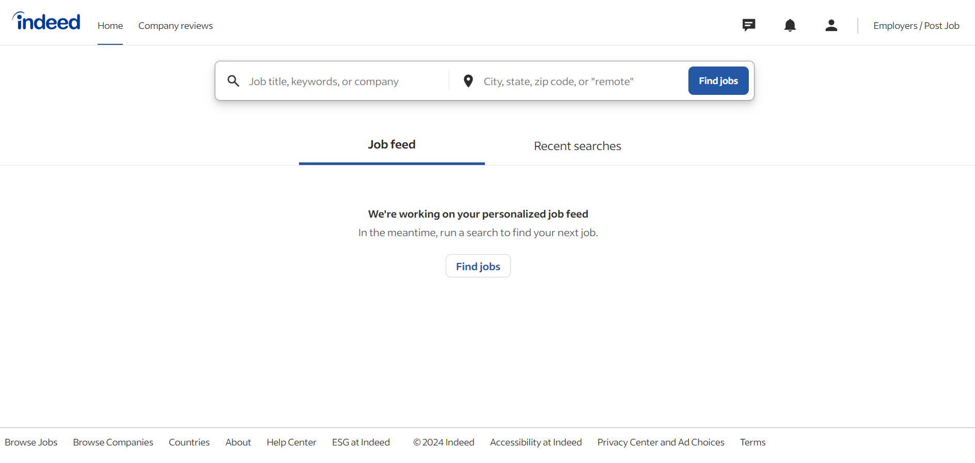

*Figure 2 Indeed*

**Advantages:**

* + Comprehensive Job Listings
  + User-Friendly Interface
  + Powerful Search Functionality
  + Resume Upload
  + Employer Tools
  + Free to use
* **Disadvantages:**
  + Spam and Scams
  + Limited Customization for Applications
  + Search Algorithm Limitations
  + Employer Bias

# **System Architecture**

## **System Overview**

**Three-Tier Architecture:**

Our system architecture is organized into three distinct tiers, each serving specific functions:

* **Presentation Tier:**
  + This tier is responsible for the user interface and interaction. It encompasses the web-based front end where users interact with the job portal's features and functionalities.
* **Application Tier:**
  + The application tier houses the core logic and functionality of the job portal. It manages processes such as job recommendations, user authentication, AI integration, and communication between the front end and the back end.
* **Data Tier:**
  + The data tier handles the storage and retrieval of information. It includes the database system that stores user profiles, job listings, and related data, ensuring data integrity and accessibility.

## **Architecture diagram**

*Figure 3 System Design*

The diagram explains how the system works together. Job seekers and recruiters use the UI Client to interact with API endpoints. These endpoints then use the core app to deal with the recommendation engine and the ORM to handle interactions with the database.

## **Use Case Diagram**

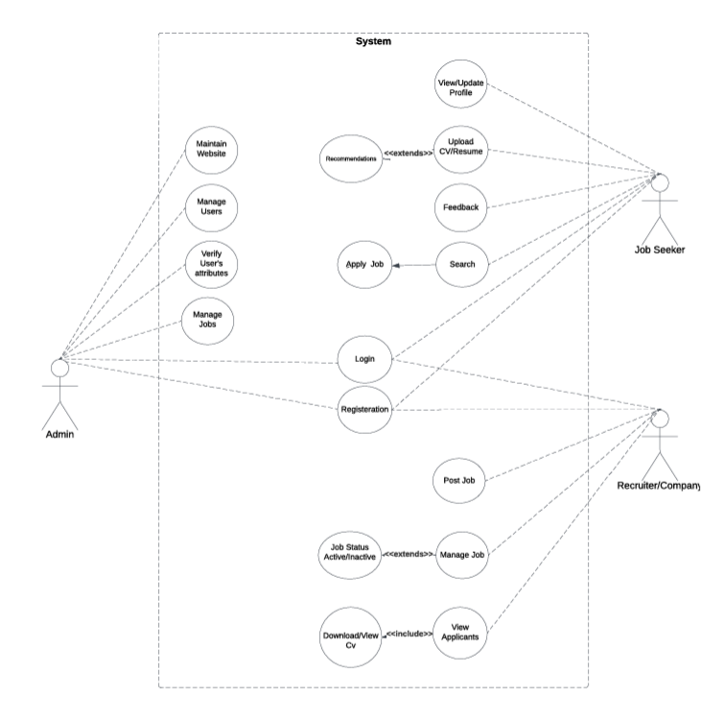

*Figure 4 Use Case Diagram*

## **Sequence Diagram**

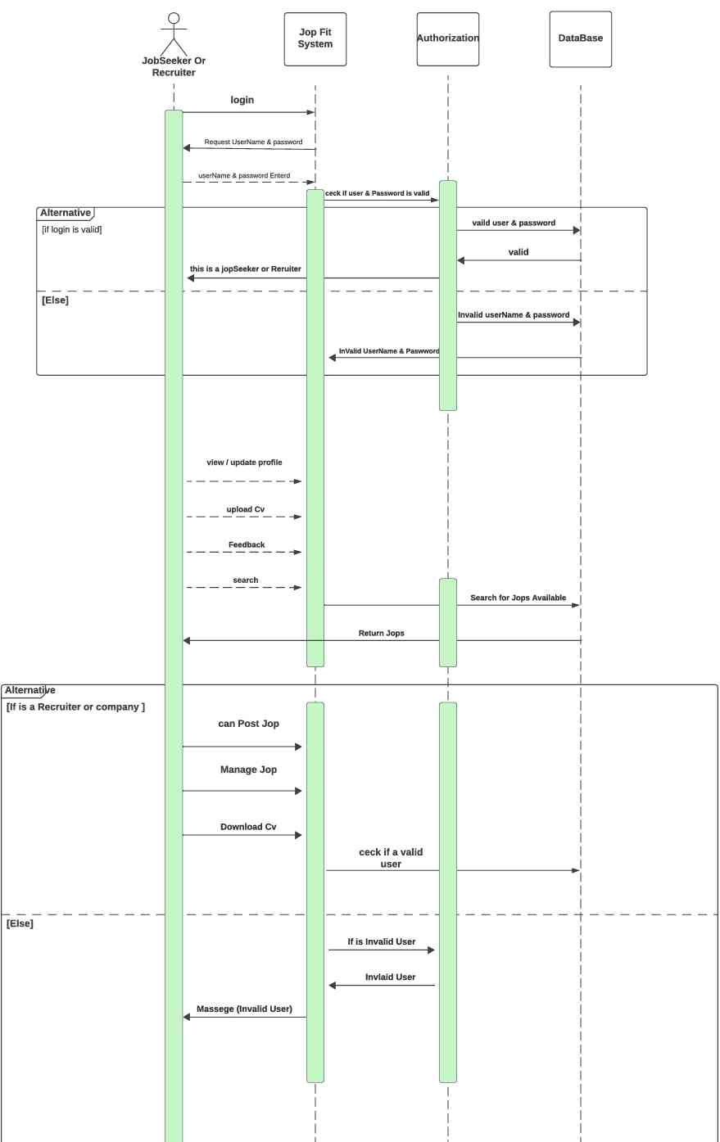

*Figure 5 Sequence Diagram*

## **Database Design**

In the context of our project, the database plays a pivotal role in ensuring the efficiency, reliability, and seamless functionality of the job portal system. The importance of the database can be underscored through several key aspects:

1. **Data Storage and Retrieval:**
   * The database serves as the central repository for storing vast amounts of crucial data, including user profiles, job listings, applications, and system configurations. This structured storage facilitates efficient retrieval, enabling quick access to relevant information.
2. **Data Integrity and Consistency:**
   * A relational database, such as MySQL, provides a framework for enforcing data integrity through constraints and relationships. This ensures that data remains accurate and consistent throughout the system, preventing discrepancies that could compromise the reliability of the job portal.
3. **Scalability:**
   * As the job portal system grows and manages an increasing volume of users, a well-designed database allows for seamless scalability. MySQL, being a relational database, offers robust scalability features, enabling the system to manage larger datasets and a growing user base.
4. **Query Performance:**
   * The relational model of MySQL allows for optimized query performance. This is crucial for quickly retrieving and displaying relevant job listings, user profiles, and other data, contributing to a responsive and user-friendly experience.
5. **Data Relationships:**
   * The relational database model excels at managing complex relationships between different entities in the system. For example, establishing relationships between users and their applications or connecting job listings with specific recruiters. This relational structure enhances the overall functionality of the job portal.
6. **ACID Compliance:**
   * MySQL ensures ACID (Atomicity, Consistency, Isolation, Durability) compliance, providing a robust foundation for transactional operations. This is essential for maintaining the integrity of the database, especially during critical operations such as user registrations, job applications, and financial transactions.
7. **Security:**
   * Database security is paramount, especially when dealing with sensitive user information. MySQL offers robust security features, including user authentication, access control, and encryption, safeguarding the confidentiality and integrity of the data stored in the system.

In conclusion, the choice of MySQL as a relational database for our job portal project is instrumental in achieving a well-structured, scalable, and high-performance system. The database not only acts as a reliable storage solution but also plays a crucial role in ensuring data integrity, security, and optimal query performance, contributing significantly to the overall success and functionality of the job portal.

*Figure 6 Database Schema Diagram*

In the ERD diagram, there are three main tables: User, Jobs, and Application. The User table is linked to other tables like user_profile, covering details such as jobs_skills, experience, education, languages, and more.

## **Server-side Architecture**

It's split into three parts:

1. **Core Functions:**
   * This part manages the essential features and tools the system needs, including the recommendation engine.
2. **Recommendation Engine Area:**
   * Inside the Core Functions, there's a specific area for the recommendation engine. This part makes it easy to add and use model scripts.
3. **API Endpoints:**
   * Dependent on the Core Functions, API Endpoints handle external interactions. They're like the system's communication hub, offering functions to users and other services.

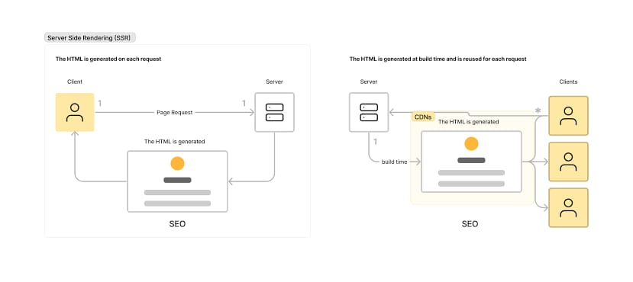

*Figure 7 Server-side Rendering*

### Main Entities in Prisma

*Figure 8 User Model*

*Figure 9 Account Model*

*Figure 10 Job Model*

*Figure 11 Application & Company Models*

*Figure 12 Profile*

*Figure 13 Experience & Education*

## **Client-side Architecture**

### **AJAX**

Is a technology that allows web developers to create dynamic, interactive websites without having to reload the page each time a user interacts with the website.

An API (Application Programming Interface) is a set of rules and protocols that allow two different applications or services to communicate with each other.

AJAX relies on an API to make requests from the server and receive data from it.

The API provides a way for the AJAX code to make requests to the server and receive data back in format that can be used by the client-side code. This allows for dynamic, interactive websites without having to reload the page each time a user interacts with it.

### **Fetching data from the server**

Another very common task in modern websites and applications is retrieving individual data items from the server to update sections of a webpage without having to load an entire new page.

Instead of the traditional model, many websites use JavaScript APIs to request data from the server and update the page content without a page load. So, when the user searches for a new product, the browser only requests the data which is needed to update the page.

*Figure 14 Data fetching*

The main API here is the Fetch API. This enables JavaScript running in a page to make an HTTP request to a server to retrieve specific resources. When the server provides them, the JavaScript can use the data to update the page, typically by using DOM manipulation APIs. The data requested is often JSON, which is a good format for transferring structured data, but can also be HTML or just text.

### **React**

React is a JavaScript Library for building interactive user interfaces.

It's widely used for building single-page applications (SPAs) due to its component-based architecture and efficient rendering using a virtual DOM.

By user interfaces (UI), we mean the elements that users see and interact with on-screen.

*Figure 15 React Diagram (1)*

By library, we mean React provides helpful functions (APIs) to build UI

### **Benefits of choosing React Technology**

Component-Based Architecture:

Encourages the development of reusable and modular components, making code more maintainable and scalable.

Virtual DOM:

Enhances performance by efficiently updating only parts of the DOM that need changes, reducing the number of direct manipulations to the actual DOM.

### **Next.js**

Next.js is a React framework that gives you building blocks to create web applications.

By framework, we mean Next.js handles the tooling and configuration needed for React, and provides additional structure, features, and optimizations for your application.

*Figure 16 React Diagram (2)*

### **Benefits of choosing Next.js Technology:**

Server-Side Rendering

Improves initial load times and SEO by rendering pages on the server before sending them to the client.

Static Site Generation

Generates static HTML pages at build time, which are served instantly to users, enhancing performance and scalability.

API Routes

Provides a way to create backend endpoints within the Next.js app, eliminating the need for a separate backend server for small to medium-sized applications

### **Material UI (MUI)**

Material-UI (MUI) is a popular React component library that implements Google’s Material Design.

It provides a wide range of pre-built components that follow Material Design principles, which can significantly speed up the development process and ensure a consistent, aesthetically pleasing user interface

### **API Integration in React**

Integrating an API in React.js involves making HTTP requests to the API endpoints and handling the data received in your React components.

There are various ways to achieve this, but the most common approach is to use the ‘fetch’ API or a library like Axios to handle the HTTP requests.

## **Authentication**

**Workflow:**

1. **User Authentication (Login):**

The user enters their credentials (username and password) into the UI (e.g., a login form).

The UI client sends a POST request to the server's authentication endpoint, typically /login, with the user credentials.

1. **Token Generation on the Server:**

Upon successful authentication, the server generates a JWT containing claims such as the user's ID, roles, and expiration time.

The server signs the JWT using a secret key to create the token.

1. **Token Transmission to the UI Client:**

The server sends the JWT back to the UI client as part of the response, usually in the JSON payload.

The UI client stores the JWT securely, often in local storage or a secure HTTP cookie.

1. **Subsequent Requests from the UI Client:**

When the user performs actions or accesses protected resources, the UI client includes the JWT in the Authorization header of HTTP requests.

1. **Server-Side Token Verification:**

The server receives the JWT in the Authorization header.

It verifies the token's integrity by checking the signature using the shared secret key.

If the signature is valid, the server extracts claims from the payload.

1. **User Authorization:**

The server uses the extracted claims to authorize the user and determine their access rights.

For example, checking if the user has the required roles or permissions to perform the requested action.

1. **Token Expiration and Refresh:**

The server checks the expiration time (exp) of the JWT to ensure it's still valid.

If the token is expired, the UI client needs to refresh it by re-authenticating the user, typically using a refresh token or by prompting the user to log in again.

*Figure 17 JWT Auth*

## **NextJs Authentication**

**Authentication Strategies**

Modern web applications commonly use several authentication strategies:

1. **OAuth/OpenID Connect (OIDC)**: Enable third-party access without sharing user credentials. Ideal for social media logins and Single Sign-On (SSO) solutions. They add an identity layer with OpenID Connect.
2. **Credentials-based login (Email + Password)**: A standard choice for web applications, where users log in with an email and password. Familiar and easy to implement, it requires robust security measures against threats like phishing.
3. **Passwordless/Token-based authentication**: Use email magic links or SMS one-time codes for secure, password-free access. Popular for its convenience and enhanced security, this method helps reduce password fatigue. Its limitation is the dependency on the user's email or phone availability.
4. **Passkeys/WebAuthn**: Use cryptographic credentials unique to each site, offering high security against phishing. Secure but new, this strategy can be difficult to implement.

Selecting an authentication strategy should align with your application's specific requirements, user interface considerations, and security objectives.

**Implementing Authentication**

In this section, we'll explore the process of adding basic email-password authentication to a web application. While this method provides a fundamental level of security, it's worth considering more advanced options like OAuth or passwordless logins for enhanced protection against common security threats. The authentication flow we'll discuss is as follows:

1. The user submits their credentials through a login form.
2. The form sends a request that is handled by an API route.
3. Upon successful verification, the process is completed, indicating the user's successful authentication.
4. If verification is unsuccessful, an error message is shown.

## **Technology Stack**

In constructing our job portal system, we have strategically assembled a technology stack at the forefront of industry trends. Our chosen stack incorporates cutting-edge solutions, emphasizing innovation and optimal performance. The backend is developed with a language known for its modern capabilities, offering a foundation for robust and scalable functionality. The data layer is implemented with a powerful database solution, enabling efficient storage and retrieval of essential information. Real-time communication is facilitated through advanced tools, enhancing user engagement. Our commitment to security and efficiency is further reflected in the incorporation of industry-leading practices, ensuring that our job portal system remains at the forefront of technological advancements in the field.

So far in our technology stack, we rely on:

1. **Front End & Back End**

Next.js:

Description: Next.js is used as a full-stack framework to handle both front-end and back-end functionalities. It allows for server-side rendering and static site generation, providing a dynamic and responsive user experience while managing server-side operations and API routes.

Key Features:

Server-Side Rendering (SSR): Enhances performance and SEO by rendering pages on the server.

Static Site Generation (SSG): Generates static HTML pages at build time.

API Routes: Simplifies the creation of backend API routes within the Next.js application.

Routing: Offers a file-based routing system, making navigation straightforward and efficient.

Full-Stack Capabilities: Combines front-end and backend logic in a single framework, streamlining development and deployment.

1. **AI Integration:**

**Python:**

Description: Python is employed for creating and integrating machine learning models. These models enhance application functionalities, such as the recommendation engine.

Key Features:

* + Machine Learning Libraries: Utilizes libraries such as TensorFlow, PyTorch, or scikit-learn for model development.
  + Data Processing: Handles data preprocessing, feature extraction, and model training.
  + Integration: Python scripts and models are integrated into the Next.js application, providing advanced AI-driven features.

1. **Database**

**MySQL with Prisma ORM:**

* **Description:** MySQL serves as the relational database management system for the application, efficiently storing and retrieving data. Prisma ORM is used to facilitate type-safe database interactions and streamline database management.
* **Key Features:**
  + **Structured Data Storage:** Organizes data into tables with predefined schemas.
  + **Type-Safe Queries:** Prisma provides an intuitive and type-safe query builder for interacting with the database.
  + **Schema Management:** Prisma schema defines the database structure and relationships, making migrations and updates straightforward.
  + **Performance Optimization:** Includes features for optimizing query performance and database access patterns.

*Figure 18 Prisma Rest*

# **AI Integration**

Finding the perfect career match can be both challenging and time-consuming. Our recommendation system is here to transform the job-seeking experience by offering intelligent and personalized job recommendations based on the job seeker’s CV which includes their skills, experience, preferences, etc.

For employers/recruiters, it ensures efficient candidate matching, resulting in better recruitment outcomes.

## **Key Highlights**

**Smart Candidate Matching:** Our recommendation system employs sophisticated algorithms to match candidates with job opportunities that align with their skills, experience, and career aspirations.

**Enhanced Employer Insights**: For employers, the system recommends candidates who best fit their job requirements, leading to more efficient and targeted hiring decisions.

**User-Centric Experience:** Prioritize user satisfaction by delivering a personalized job search experience that adapts to individual preferences and career goals.

**Machine Learning Algorithms**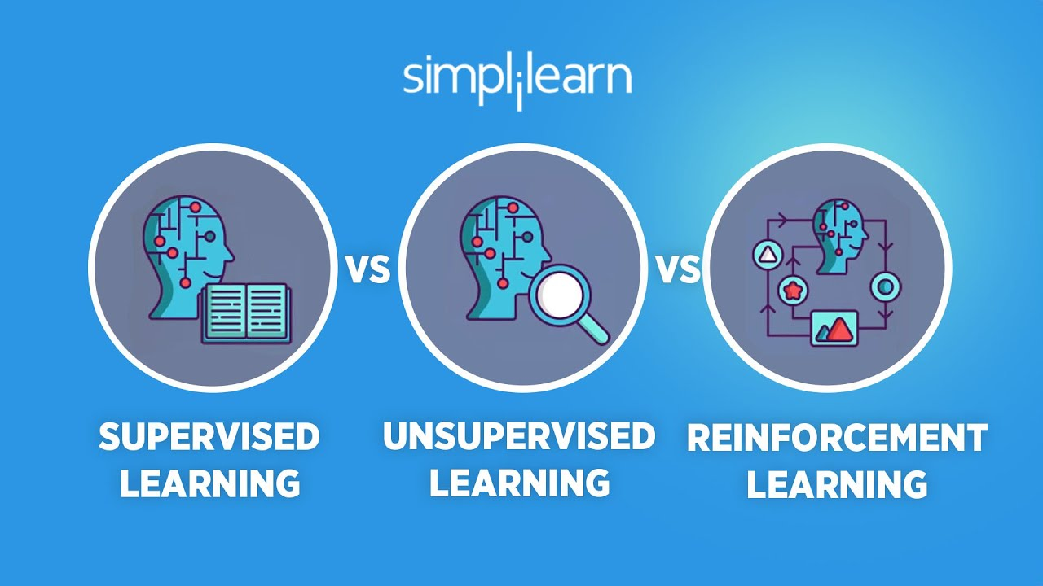

**Supervised Learning**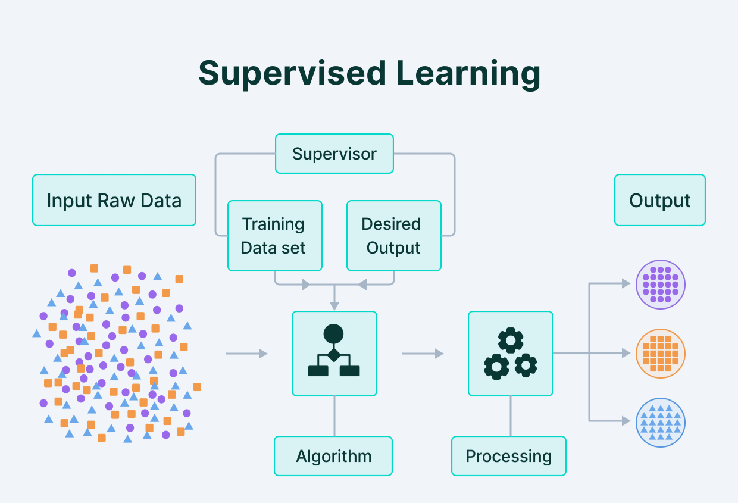

**Supervised learning** is a type of machine learning where the algorithm is trained on a **labelled** dataset, which means that each training example is paired with an output label.

These are the technique(s) we implemented on our project using **Supervised Machine Learning.**

1. **Support Vector Machines (SVM)**

**Purpose:** Classification and regression tasks.

**Description:** It finds the hyperplane that best separates the classes in the feature space. For nonlinear problems, it can use kernel functions to transform the data into a higher-dimensional space.

**Example:** Image classification tasks.

2. **Decision Tree**

**Purpose:** Classification and regression tasks.

**Description:** A tree-like model of decisions where each internal node represents a test on an attribute, each branch represents the outcome of the test, and each leaf node represents a class label or regression value.

**Example:** Diagnosing diseases based on symptoms.

3. **Random Forests**

**Purpose:** Classification and regression tasks.

**Description:** An ensemble method that builds multiple decision trees and merges them together to get a more accurate and stable prediction.

**Example:** Credit scoring systems.

**Unsupervised Learning**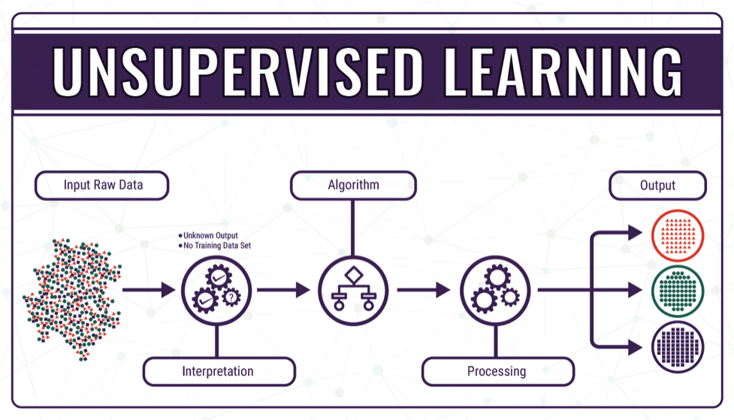

Supervised learning is a type of machine learning where the algorithm is trained on an **unlabelled** dataset.

These are the technique(s) we implemented on our project using **Unsupervised Machine Learning.**

**K-Means Clustering**

**Purpose:** Partitioning data into distinct groups (clusters).

**Description:** The algorithm divides the data into 𝑘 clusters, where each data point belongs to the cluster with the nearest mean, serving as a prototype of the cluster.

**Example:** Market segmentation to group customers with similar behaviours.

**Natural Language Processing (NLP)**

**Purpose:** Is to bridge the communication gap between humans and machines

**Description**: NLP empowers computers to interpret human language

**Example:** Allows smartphones to understand human voice commands.

## **Reinforcement Learning**

## 

Reinforcement learning (RL) is a type of machine learning (ML) where an agent learns to make decisions by interacting with an environment, using a trial-and-error approach to maximize cumulative rewards.

We did not implement **RL** in our project due to having better outcomes and results from Supervised and Unsupervised Machine Learning.  
  
**1. Q-Learning**

**Purpose:** Learning optimal action-value functions.

**Description:** It learns an action-value function that gives the expected utility of taking a particular action in a given state and following the optimal policy thereafter.

**Example:** Training a robot to navigate a maze.

**2. Deep Q-Networks (DQN)**

**Purpose:** Extending Q-learning to deep neural networks.

**Description:** Uses a neural network to approximate the action-value function, allowing for more complex state representations and potentially faster learning.

**Example:** Playing Atari games where the agent directly observes pixel data.

## **Types of Recommendations systems**

In job websites, there are four main ways to recommend jobs. By using these different methods, the suggestions become more diverse and accurate. It's helpful to mix these methods to get the best results for job recommendations.

### **Content-Based Recommendations**

**How It Works**

In the content-based approach, our recommendation system analyses the inherent features of jobs and jobseekersto generate precise recommendations. By focusing on key attributes provided in their CV/Resume such as skills, education, qualifications, and preferences, the system tailors suggestions that align with individual user profiles.

**Strengths**

* Personalized to individual user preferences.
* Adaptive. Captures changes in user’s interests.
* Recommends unpopular products, for instance if an employer/recruiter is looking for or hiring a Software Engineer that only speaks Spanish, then the system will target Software Engineers that speaks Spanish.
* Items recommended for one user do not depend on other users.

**Considerations**

* Limited diversity in recommendations.
* Depends heavily on details. Needs good information about items to work well.
* Takes time to adjust to changing user preferences effectively.

### **Collaborative Filtering**

**How It Works**

Collaborative filtering relies on collective user behaviour to make recommendations. By identifying patterns and similarities among job seekers, the system suggests jobs that align with the preferences and actions of job seekers with similar profiles.

**Strengths**

* The algorithm understands what you might like through natural preferences by observing others with similar tastes.
* Versatile suggestions where it recommends various jobs.

**Considerations**

* Faces difficulty in making accurate recommendations for new job seekers with no history of preferences established.
* Data Sparsity can be found due to the lack of sufficient data.

### **Hybrid Recommendations**

**How it works**

Within our job portal framework, Hybrid Recommendations seamlessly integrate two powerful methods: content-based and collaborative filtering. Think of it as an experienced job matchmaker. It not only understands your individual job preferences but also learns from the collective choices of other job seekers who share similarities with you.

**Strengths**

* Offers personalised job suggestions by examining your CV/Resume contents with precision.
* Ability to expand recommendations to various job types, ensuring more complete view to offered jobs by recruiters.
* Also adapts to changes in job seeker’s behaviour and preferences.

**Considerations**

* Implementation can be complex; the combination requires careful setup and management.
* Regular maintenance and adjustments are necessary to maintain performance.

According to our research, choosing the Content-Based Recommendation System for our AI Integration System means we prioritize personalized and accurate job suggestions to job seekers. This system pays attention to job details and contents within the CVs/Resumes, making it great for delivering recommendations that really fit the job seeker’s preferences, unlike other algorithms, this algorithm offers a more straightforward experience for job seekers even if you’re new to the platform. So, by using the Content-Based Recommendation System, we aim to make your job search experience more personalized and satisfying.

## **Dataset**

**First Dataset**

In this section of our documentation, we will be explaining the dataset used in our system.

**• Title (Job Title)**

In our first column the Title column is necessary that is going to be provided by the recruiter to display the jobs available relevant to its location to the job seeker in our case this column is needed hence it has a proportional relationship with our sixth column (Skills) we will talk about it more below in our “Skills” sections below.

**• Company**

In our second column it represents the recruiter’s company name that is assigned to the Job provided in the system.

**• Location**

In our third column the Location column provides the job seeker an idea of where the job is going to be located by the recruiter.

**• Type**

In our fourth column the Type column gives an insight to the job seeker whether the job will be Full-time job or Part-time job.

**• Level**

In our fifth column the Level column informs the job seeker what level the job position offers for example, entry level, experienced, manager or work from home.

**• YearsExp**

In our sixth column the YearsExp column is needed to provide an idea to the job seeker how many years of experience is needed to apply for the job position.

**• Country**

In our seventh column the Country column provides the country allocated with the job by the recruiter.

**• Skills**

In our last column the Skills column is yet to be one of the most important if not the most important column in our dataset.

Hence, it’s the column we will be applying our algorithm to, in our case it’s the recommendation system algorithms where we will be fetching the data and most important contents provided within the CV/Resume to recommend the job seeker the best suited jobs provided in our first column “Title”.

**Second Dataset**

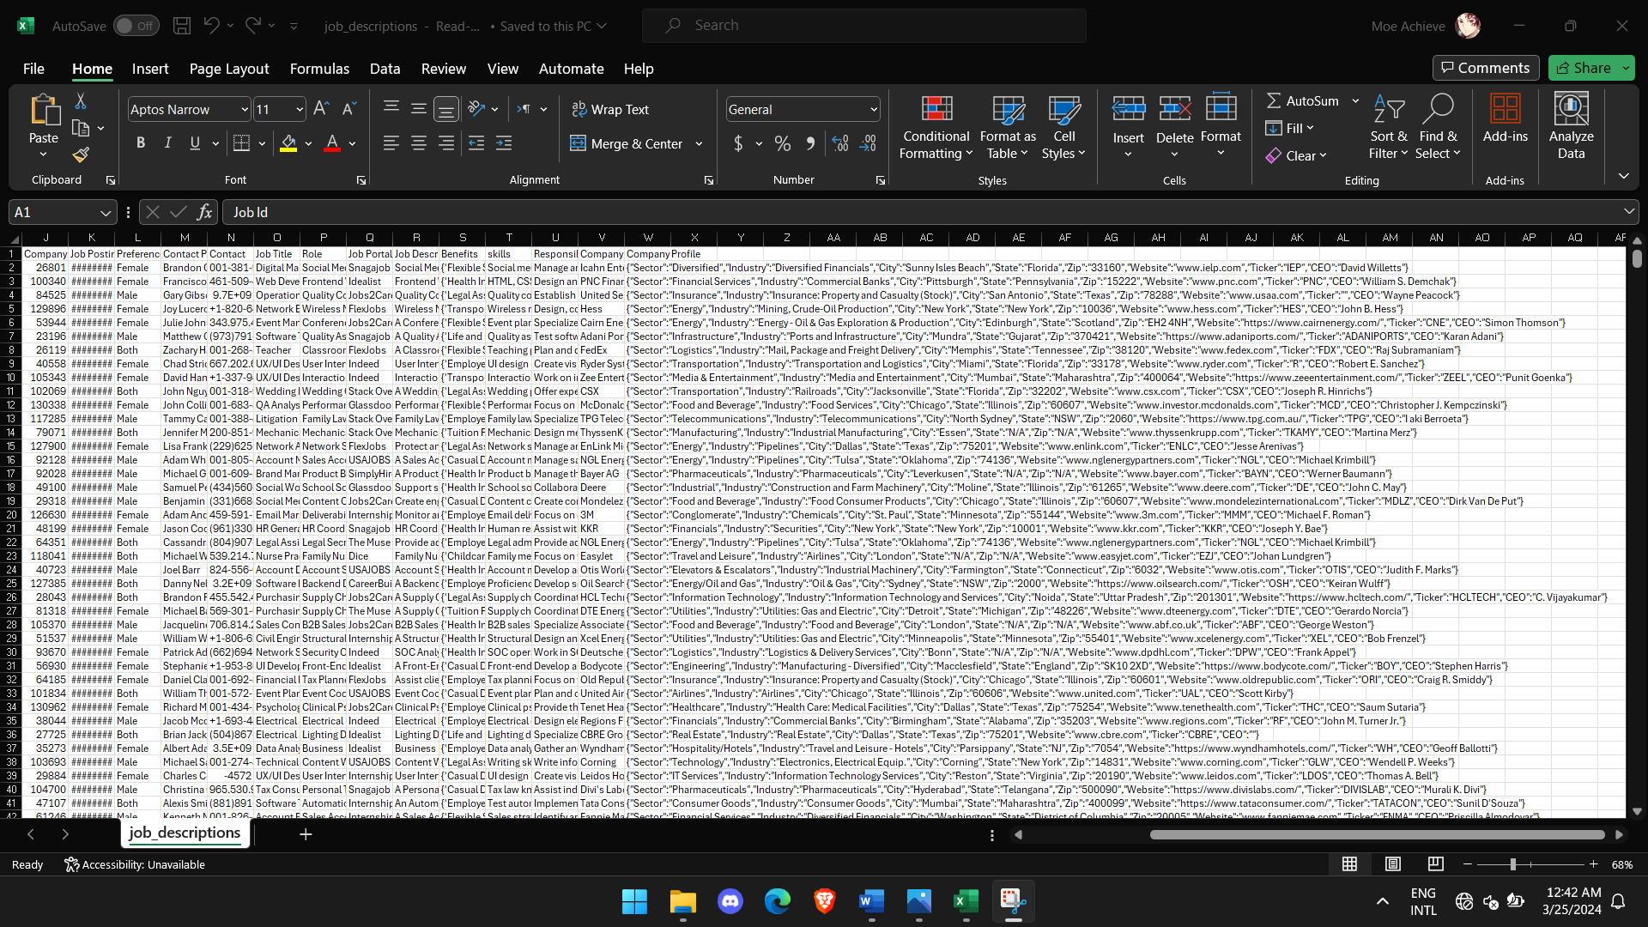

*Figure 19 Second Dataset*

As we can clearly see, our second dataset is filled with completed data, but it also led to coding issues, in which the data was so large that the accuracy score was 1.0 (Overfitting) in the Title column.

Also, we calculated the Location column accuracy score and it was below 0.05 (Underfitting), so this dataset was not ideal.

**Third Dataset**

*Figure 20 Accuracy Score Third Dataset*

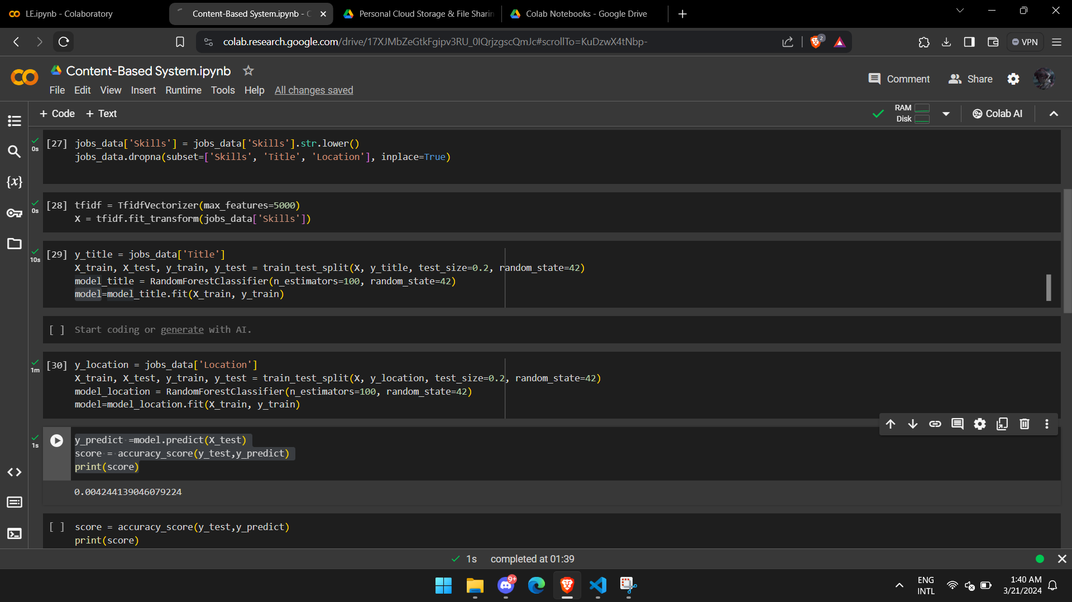

*Figure 21 Third Dataset*

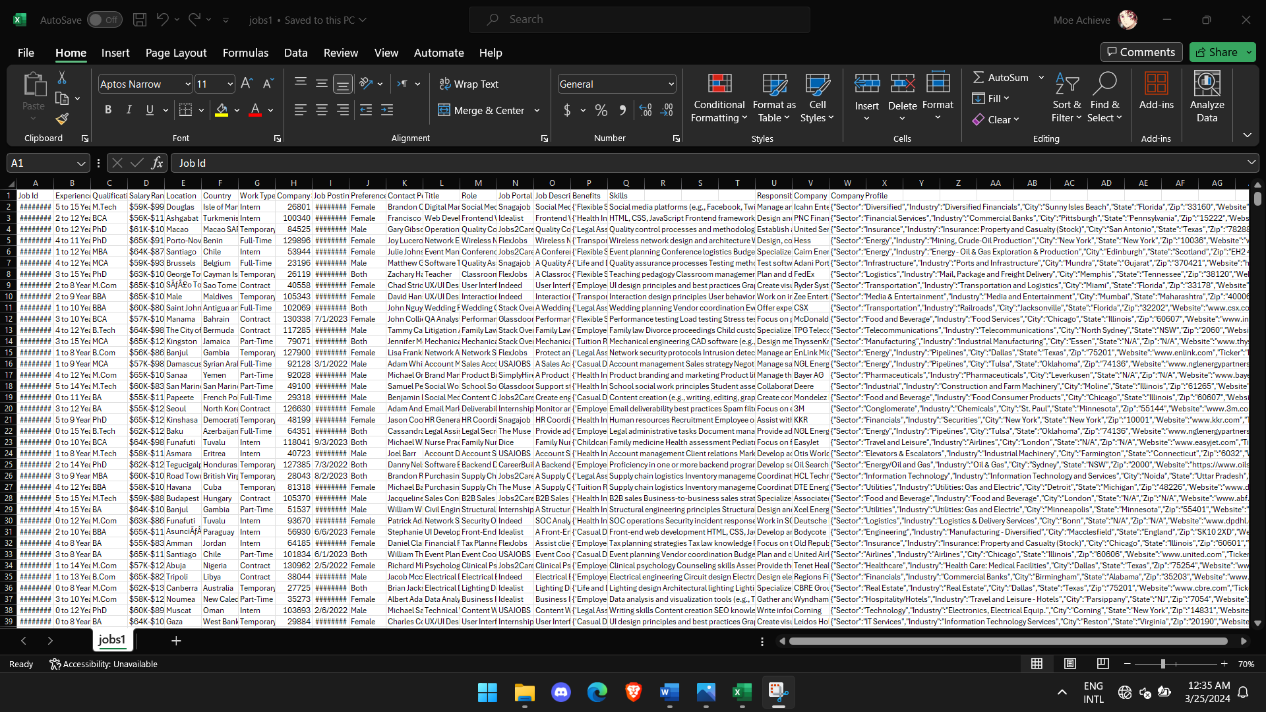Here also, our dataset is not ideal due to the very low accuracy score described in the picture (0.004) it was underfitted for our results so, we are going to move on to our final and best fitted dataset.

**Current Dataset**

*Figure 22 Current Dataset*

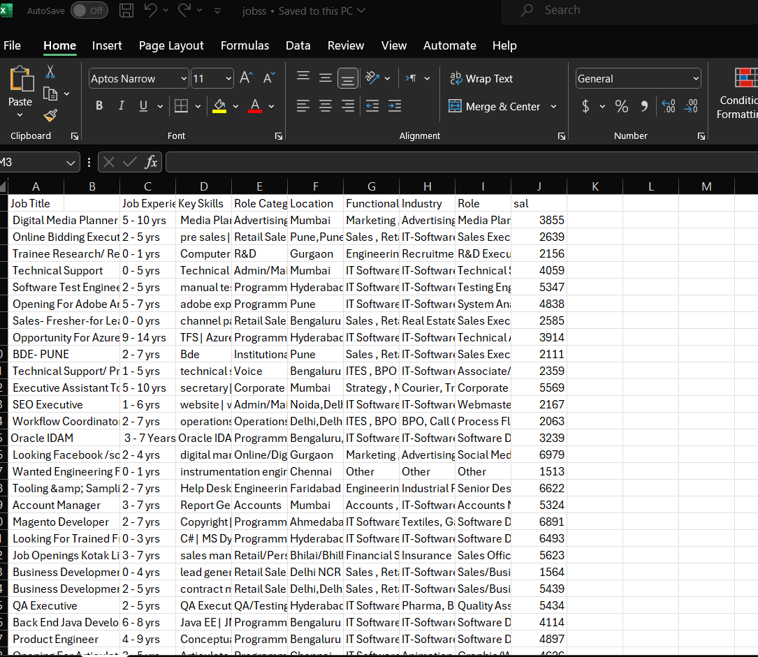

**Job Title**

In our first column the Job Title column is necessary that is going to be provided by the recruiter to display the jobs available to the job seeker in our case this column is needed hence it has a proportional relationship with our sixth column (Key Skills) we will talk about it more below in our “Key skills” sections below

**Job Experience**

In our second column the Job Experience Required column is also a column that gives the job seeker the required job experience to apply for a certain job provided by the recruiter.

**Key Skills**

In our third column the Key Skills column is yet to be one of the most important if not the most important column in our dataset.

Hence, it’s the column we will be applying our algorithm to, in our case it’s the recommendation system algorithms where we will be fetching the data and most important contents provided within the CV/Resume to recommend the job seeker the best suited jobs provided in our first column “Job Title”.

**Role Category**

In our fourth column the Role Category column is needed to categorize and classify each job that is provided by the recruiter, so the job seeker could understand the kind of roles available within the job.

**Location**

In our fifth column the Location column provides the job seeker

an idea of where the job is going to be located by the recruiter.

**Functional Area**

In our sixth column the Functional Area column provides the job seeker an idea of which fields of profession categories their provided CV/Resume can be applied to, it’s also related to our fourth column in the dataset “Role Category” in which it collects the categories that the CV/Resume can fit into.

**Industry**

In our seventh column the industry column refers to the sector or field in which the recruiter’s organisation/company operates.

**Roles**

In our second to last and last column the Role column provides a more specific information than our seventh column “Role Category” to the job seeker,

It specifies the exact job titles or specific roles within the broader category provided by the recruiter, basically it gives the job seeker an idea of what exact role they will work in the organisation.

**Job Salary (sal)**

In our last column the Job Salary column is a column that gives the job seeker an idea of the salary to expect within the job provided by the recruiter the job salary can be provided or not disclosed by the recruiter.

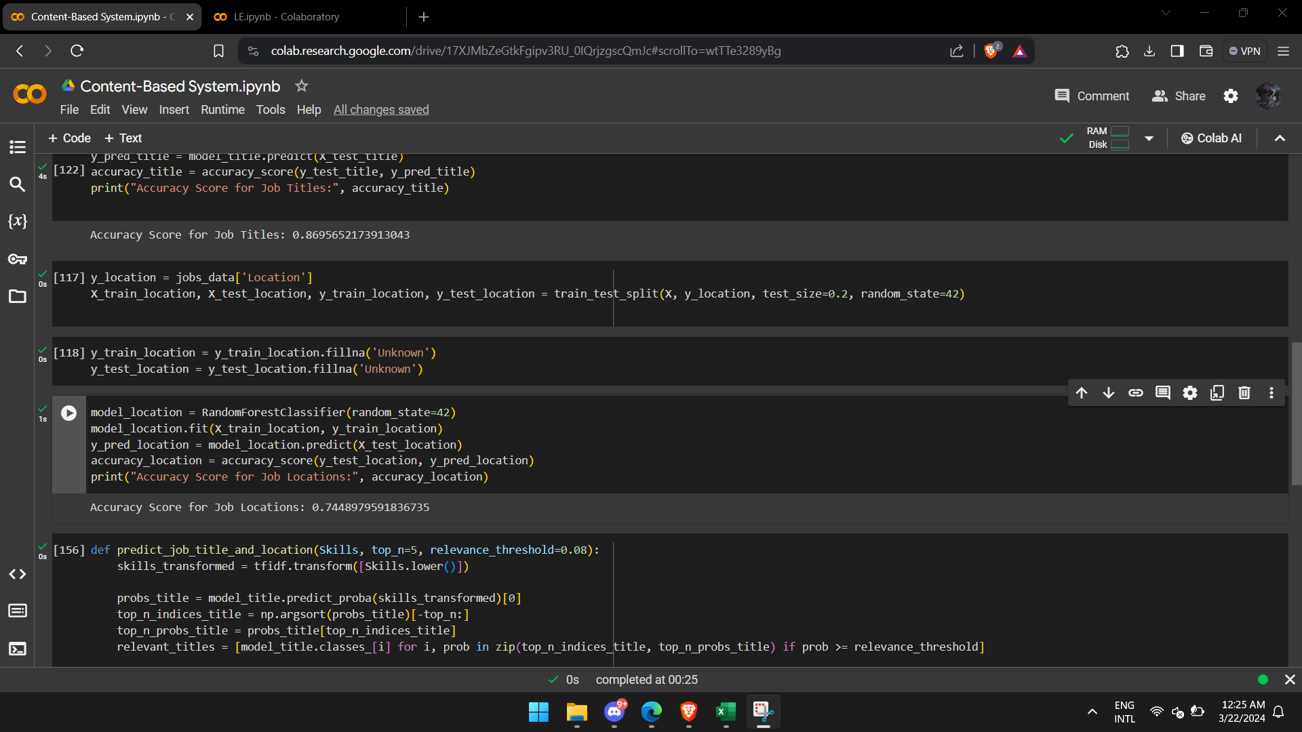

*Figure 23 Accuracy Score Current Dataset*

As we can see, this is the best fitted dataset between other datasets mentioned, the dataset is clean with enough information, and by default it was already showing better accuracy score, but we will fix it to make it better in the next pictures.

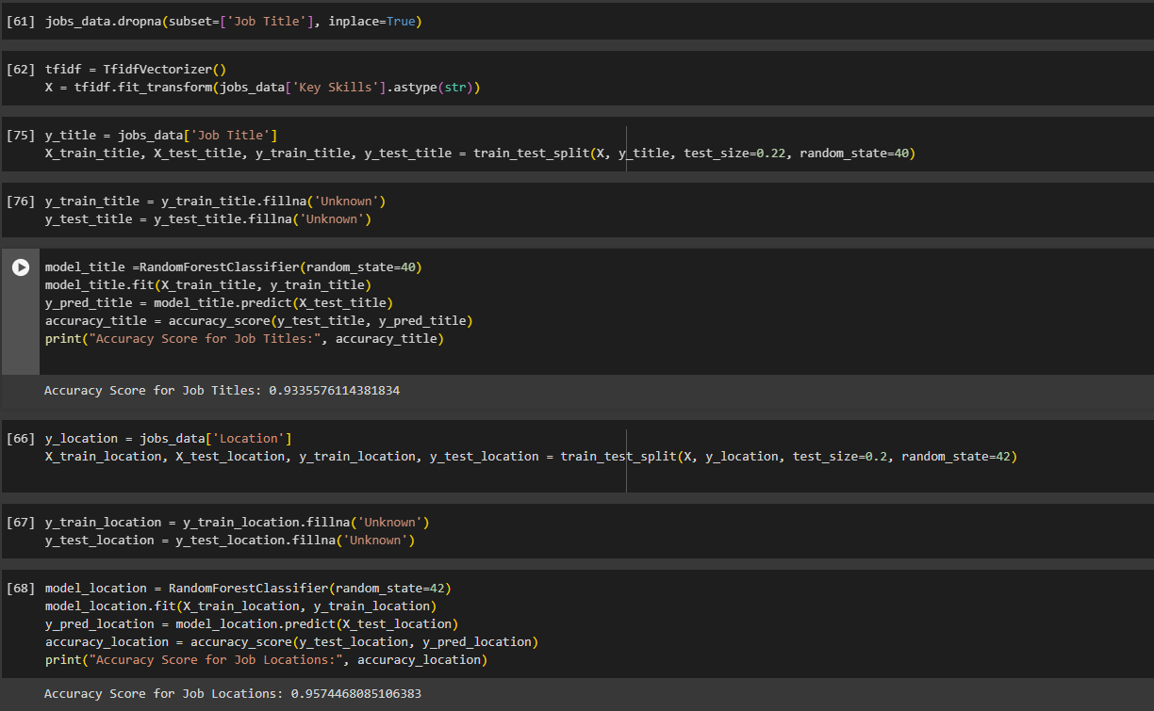*Figure 24 Updated Accuracy Scores Current Dataset*

As we can see, after some coding adjustments we acquired a very good accuracy score, 0.93+ for both Job Titles and Job Locations columns, therefore we chose this dataset to be our best fitted dataset.

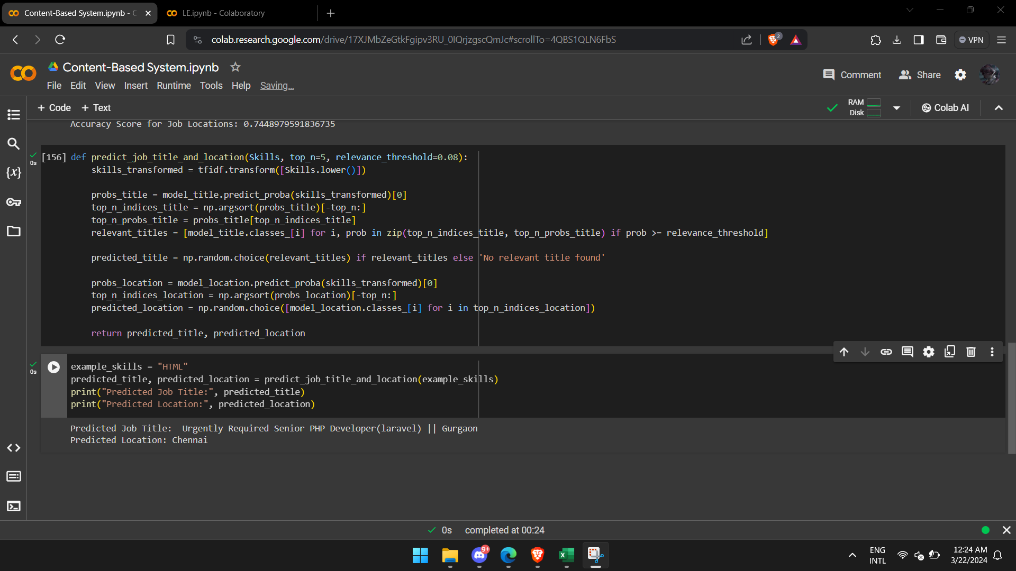

*Figure 25 Output Current Dataset*

Due to our coding adjustments, the model can predict best fitted outputs which are the job title and location, with much more efficiency.

The Final Dataset’s data was gathered from multiple references mentioned below in **References**.

# **AI Endpoint**

Our Flask code is provided below in the following **Appendix** section in the document.

# **Flask Overview**

**Flask** is a lightweight and flexible web framework for Python that allows developers to create web applications quickly and easily. It is designed to be simple and unopinionated, giving developers the freedom to structure their projects as they see fit. Flask provides essential tools and libraries to build web applications, including URL routing, request handling, and templating.

**Why Use Flask?**

* **Simplicity**: Flask is minimalistic and easy to set up, making it ideal for small to medium-sized applications.
* **Flexibility**: It doesn't impose a specific way of doing things, allowing developers to use the libraries and tools they prefer.
* **Extensibility**: Flask can be extended with numerous extensions to add functionality, such as database integration, form handling, and authentication.
* **Community**: It has a large and active community, providing plenty of resources, tutorials, and third-party extensions.

**Explanation of Using One Endpoint**

A single endpoint is utilized to serve a specific function within the application.

**Endpoint: /predict**

* **Purpose**: This endpoint is designed to predict the job title and location based on the skills provided in the request.
* **Method**: It uses the POST method, which is suitable for requests that involve sending data to the server to be processed.
* **Request Handling**: The endpoint expects a JSON object containing the user's skills and optionally, the parameters top_n and relevance_threshold.
* **Data Processing**: The endpoint transforms the input skills using a pre-trained TF-IDF vectorizer, then uses two Random Forest models to predict job titles and locations.
* **Response**: It returns a JSON response with the predicted job title and location.

Using a single endpoint in this context is beneficial for several reasons:

1. **Simplicity**: Having a single endpoint keeps the application straightforward and easy to understand, especially for developers who are maintaining or extending the codebase.
2. **Focus**: This endpoint focuses on a single responsibility—predicting job-related information based on skills—making it easier to manage and debug.
3. **Scalability**: If additional functionalities are needed in the future, new endpoints can be added without affecting the existing one. For instance, separate endpoints could be created for adding new jobs, updating job information, or retrieving job details.
4. **Efficiency**: Handling both job title and location predictions in one request reduces the need for multiple HTTP requests from the client, improving efficiency and reducing latency.

# **UI/UX Design**

UI and UX design are critical components of product development, especially in digital environments like websites, mobile applications, and software. They are interconnected disciplines that focus on different aspects of the user's interaction with a product.

# **UI Design**

The User Interface (UI) section of our documentation delves into the visual and interactive elements that define the user experience within our job portal system. This segment provides a comprehensive overview of the design, layout, and functionality of the portal's interface. From the landing page to individual job listings and user profiles, this section explores how users will interact with the system, emphasizing a user-centric approach. By focusing on intuitive navigation, responsive design, and aesthetic appeal, we aim to create a seamless and engaging experience for both job seekers and recruiters. This UI section is structured to guide developers and stakeholders through the various components, ensuring a thorough understanding of the visual aspects that contribute to the overall success of our job portal.

# **UX Design**

UX design focuses on the overall experience of the user as they interact with the product. It aims to create products that are not only functional but also enjoyable to use.

## **Preview**

*Figure 26 Home Page*

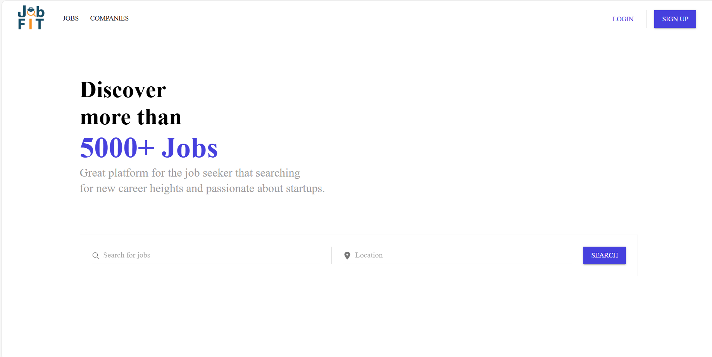

A home page is the main web page that a visitor will view when they navigate to a website via a search engine, and it may also function as a landing page to attract visitors. In some cases, the home page is a site directory, particularly when a website has multiple home pages.

Our home page highlights are simplicity and straight-forward to aid the user that interacts with our home page, the user can navigate easily without being confused because everything is stated on the page and functions as labelled.

As shown in **Figure 13 Home page**, we included a search bar where the user can search for their desired job, if the user wants to search for a job generally without specifying their location, they can search for the desired job without adding location and then our page will navigate to all available jobs with multiple locations, and if they want to specify the location, then they can do so and our page will navigate and result the jobs with the location entered.

Also, the user can navigate directly to the **JOBS** tab to view all possible jobs listed in our program in general.

As well as the **COMPANIES** tab to view the companies and their job listing and to gain more information about them.

We also added **LOGIN** and **SIGN UP** for the user to create their accounts or log into their existing account.

*Figure 27 Sign Up*

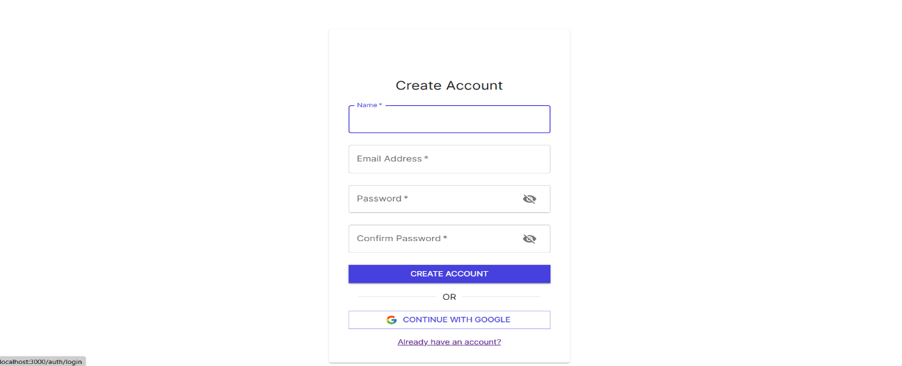

Here is our **Sign up** page where the user can create their account and register in our database.

As we can see, we went for a simple design the gives the user a straightforward approach, where the user can include their name, email address and password with a confirmation in order to ensure integrity.

We also provided **Show password** button in **Password & Confirm Password** fields in order to aid and help the user to ensure they entered their password correctly.

If the user does not want to include all of their information like we stated above, the user can create their account using their **Google Email** for an easier approach.

If the user already has an account registered in our system, we included at the very bottom of the UI `**Already have an account?`** button in order to navigate them to the **Log in** page.

*Figure 28 Log in page*



Here is our **Log in** page, we also went for a minimal simplistic approach to make it easy on the user to log into their account, we also provided the same approach for the **Show password** button to ensure the user that they entered their password correctly.  
As stated above, we also provided logging in with **Google** so they can log into our system directly using **Google** account that is registered in our system.

If the user did not have an account, **`Don’t have an account?`** button comes in handy and navigates them back to **Sign up** page.

*Figure 29 Profile page*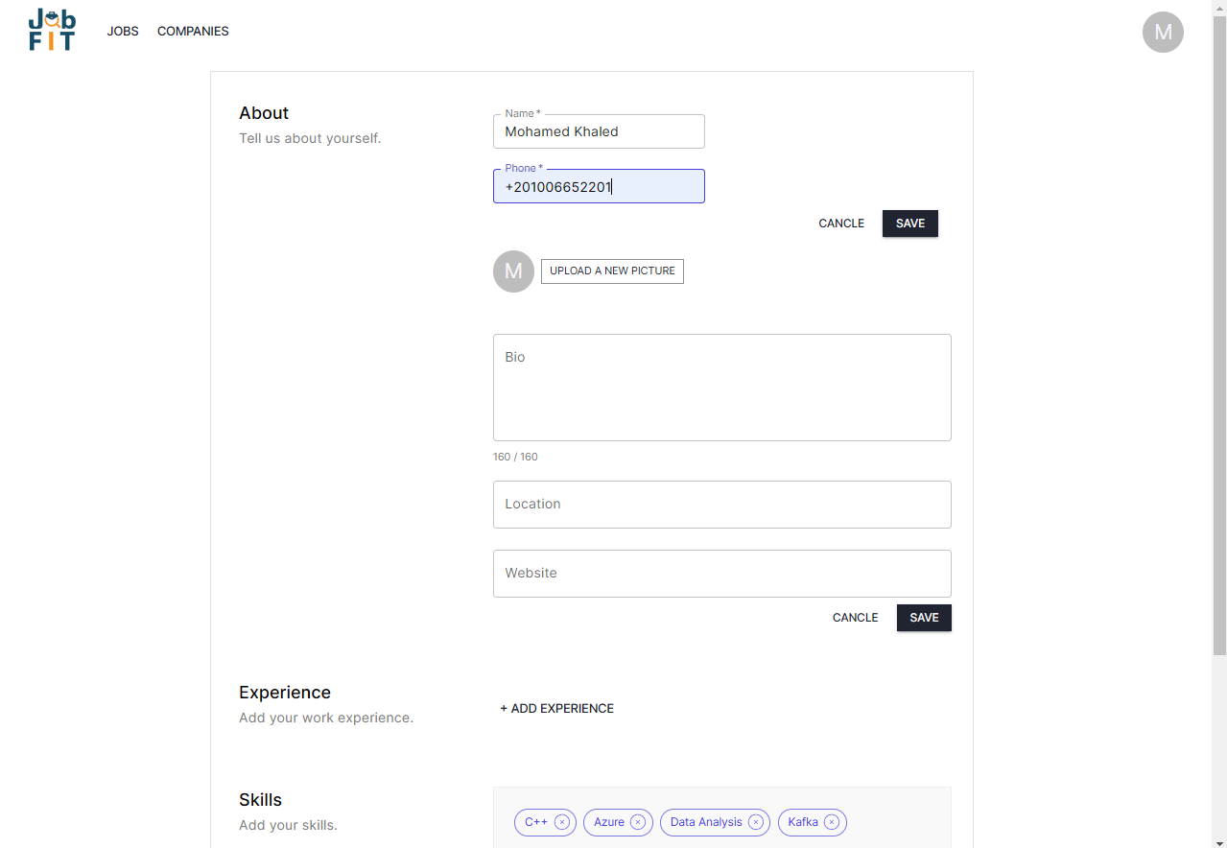

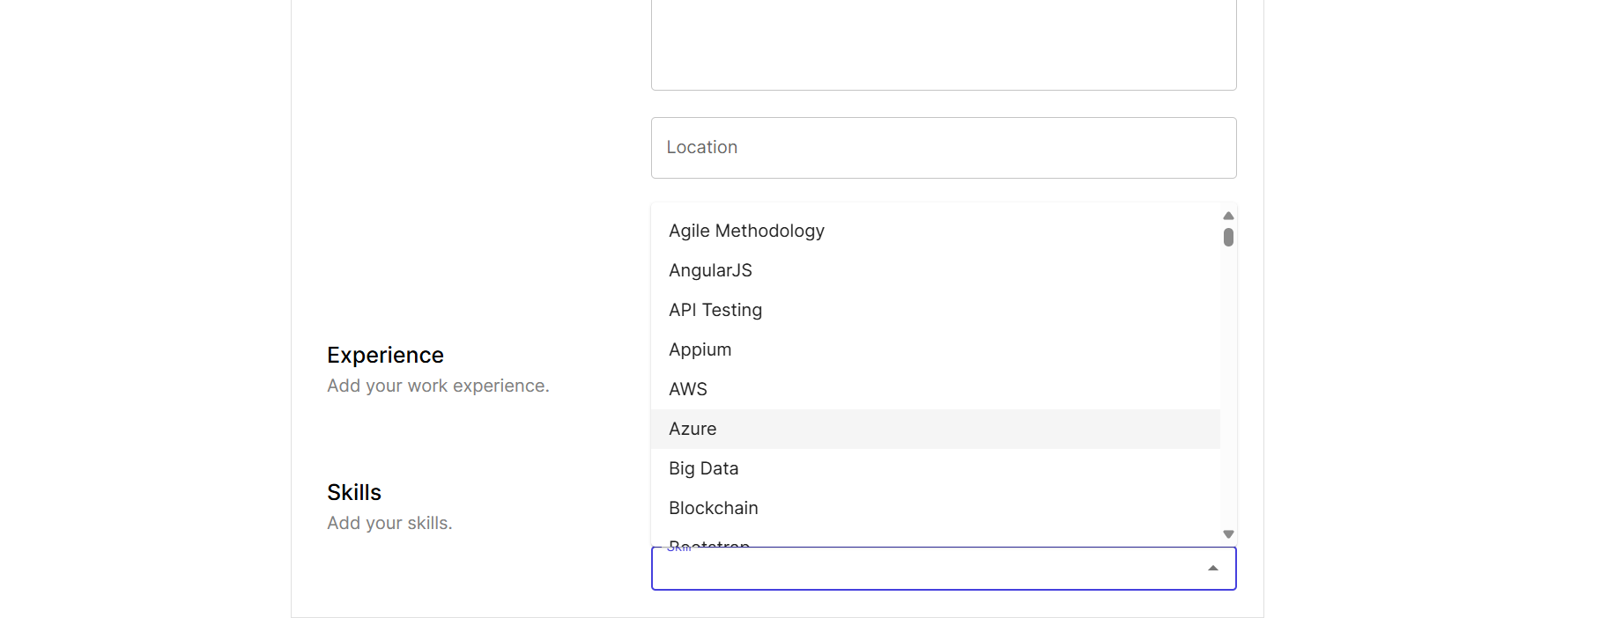

Here the user can manage and edit that is needed in their profile.

In **About** section the user is required to provide their names and their phone number, if their satisfied with just providing those two or continue later, they can either cancel or save the process by clicking on the **Cancel/Save** Buttons.

The user can upload their pictures for their profile, tell more about themselves in the **Bio** text box, provide their location as well as their website if they got one.

In the **Experience** section, the user can list all their past work experiences to improve their **CV/Resume**.

The **Skill** section allows the user to add their personal skills through either clicking the provided skills suggestions that we included on our system, or through a drop down box that has lists of experiences they can add, if the skills they got are not in our system then they can simply just write it down in our text box.

The **Page layout** is based on our home page where we provide the **Companies** and **Jobs** tab to navigate to their pages, they also can navigate back to the home page by simply clicking on our **JobFit** logo.

*Figure 30 Jobs Page*

The **Job** page provided everything for the about the jobsfor the **Jobseeker**,

Where all jobs are listed on the left side of our panel, in which the jobs are previewed briefly below each other providing the job name, location of the job, company that listed the job, type in which whether the job is full-time, part-time, internship, etc.

The user can also search for jobs to filter the jobs provided based on the jobs they searched for, or search by location to filter the jobs provided based on the location provided.

When clicked on the desired job, the right panel appears stating every detail that is within the job and its description, which helps the user to learn more about the job, and then we provided an **Apply** button to help the user in applying for the job if they are satisfied with the job.

Upon clicking on the **Apply button** the user can provide their cover letter in the cover letter text box and upload their **resume/cv** in whatever format like .pdf, .doc, etc.

If the user wishes to confirm their application they can click on the apply button or cancel the application if they are not satisfied.

*Figure 31 Admin Dashboard***A screenshot of a computer

Description automatically generated**

An **Admin Dashboard** is a single screen that includes all crucial information. In contrast, an admin or control panel allows for certain actions. It enables administrators to conduct efficient management, control the system's performance, and implement the required changes.

Through this page the **Admin** can:

Manage every administrative task provided in the system like banning, upgrading etc. Through interactive buttons provided.

Our dashboard helps the **Admin** to navigate easily by searching or navigating through every task.

*Figure 32 Recruiter Dashboard*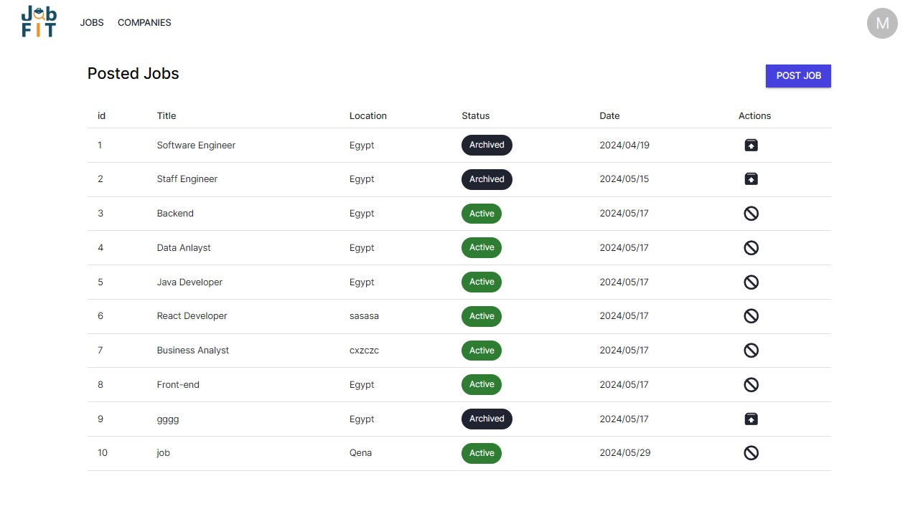

The **recruiter** is responsible for attracting, hiring, and onboarding new employees while ensuring compliance with labor laws.

They work with management and employees.

Our **Admin Dashboard** aids the **recruiter** to their responsibilities by having an easy interface, and buttons which helps them to **post job** and view them thoroughly.

*Figure 33 Application page***A screenshot of a computer

Description automatically generated**

This page shows the **Jobseeker** the jobs they applied for, the date of application, and the status of whether they got accepted or rejected.

# **Conclusion**

The development of our advanced Job Portal System aims to revolutionize the job market by addressing its complexities and inefficiencies, offering enhanced experiences for both job seekers and recruiters. Through the integration of cutting-edge technologies and innovative strategies, our system provides a robust solution to streamline job matching processes and elevate overall user satisfaction.

**Key Highlights of the Project:**

* **Innovative Job Fit Analyzer**: Powered by AI and advanced software, our Job Fit Analyzer sets new standards in job matching with personalized recommendations and efficient algorithms.
* **Comprehensive Functionality**: The system caters comprehensively to diverse user needs, featuring sophisticated tools for job seekers (profile management, AI-driven job recommendations) and recruiters (job posting, applicant management).
* **Secure and Scalable Architecture**: Built on a secure three-tier architecture, integrating Next.js for frontend and backend capabilities, MySQL with Prisma ORM for robust data management, and Flask for AI model deployment. This architecture ensures scalability, performance optimization, and data security.
* **User-Centric Design**: Prioritizing user experience, the system employs Material-UI for aesthetic consistency, AJAX for dynamic interactions, and Next.js for server-side rendering and API handling.
* **Authentication and Security**: Utilizing JWT-based authentication for secure user access and authorization, ensuring the integrity and protection of user data.
* **AI Integration**: Incorporating machine learning models such as SVM and Decision Trees via Flask endpoints for intelligent job recommendation systems. This enables precise candidate matching and enhances recruitment outcomes.
* **Recommendation Systems**: Leveraging Content-Based Recommendation Systems to deliver personalized job suggestions based on user CV/resume content, ensuring relevance and user satisfaction.

# **Future Work**

## **Implementation**

#### Long-Term Vision

Our long-term goal is to transition from a semester-based project to a real-world application, continually improving our artificial intelligence, frontend, backend, and feature set. This evolution will involve:

* **AI Enhancements**: Advancing our AI capabilities to provide more intelligent and adaptive solutions.
* **Frontend Improvements**: Elevating the user experience through a more intuitive and responsive interface.
* **Backend Development**: Strengthening our backend infrastructure to support scalability, security, and high performance.
* **Feature Expansion**: Continuously adding new features and functionalities to meet user needs and industry standards.

By focusing on these areas, we aim to deliver a cutting-edge, real-world application that addresses the evolving demands of our users and stakeholders.

# **References**

[1]

“Google Job Skills,” *www.kaggle.com*. https://www.kaggle.com/datasets/niyamatalmass/google-job-skills (accessed Jun. 10, 2024).

*NOTE* ((OUR DATASET WAS INSPIRED AND IMPLEMENTED ON GOOGLE DATASET REFERENCE PROVIDED))

[2]

“Designing a Database for an Online Job Portal,” *Vertabelo Data Modeler*, Nov. 15, 2016. <https://vertabelo.com/blog/designing-a-database-for-an-online-job-portal/>

[3]

Z. Pajorska, “Guide to Recommendation System: Types, Selection Criteria, How to Build One,” Stratoflow, Oct. 19, 2023.<https://stratoflow.com/guide-to-recommendation-system/>

[4]

“What is the relationship between AJAX and an API?,” Quora.(accessed Jun. 10, 202 4).<https://www.quora.com/What-is-the-relationship-between-AJAX-and-an-API>

[5]

“Client-side web APIs,” *MDN Web Docs*, Jun. 19, 2018. <https://developer.mozilla.org/en-US/docs/Learn/JavaScript/Client-side_web_APIs>

[6]

“Jobs in Egypt - WUZZUF | وظف.كوم,” *WUZZUF*.   
<https://wuzzuf.net/jobs/egypt>

[7]

indeed, “Job Search | Indeed,” *www.indeed.com*, 2022.

<https://indeed.com>

‌

‌

## **Appendix**

**Flask Code:**

import numpy as np

import pandas as pd

from flask import Flask, request, jsonify

from sklearn.feature_extraction.text import TfidfVectorizer

from sklearn.ensemble import RandomForestClassifier

from fuzzywuzzy import fuzz

app = Flask(__name__)

file_path = 'jobss.csv'

jobs_data = pd.read_csv(file_path)

jobs_data.dropna(subset=['Job Title'], inplace=True)

tfidf = TfidfVectorizer()

X = tfidf.fit_transform(jobs_data['Key Skills'].astype(str))

y_title = jobs_data['Job Title']

model_title = RandomForestClassifier(random_state=40)

model_title.fit(X, y_title)

y_location = jobs_data['Location']

model_location = RandomForestClassifier(random_state=42)

model_location.fit(X, y_location)

def predict_job_title_and_location(skills, top_n=5, relevance_threshold=0.08):

skills_transformed = tfidf.transform([skills.lower()])

probs_title = model_title.predict_proba(skills_transformed)[0]

top_n_indices_title = np.argsort(probs_title)[-top_n:]

top_n_probs_title = probs_title[top_n_indices_title]

relevant_titles = [model_title.classes_[i] for i, prob in zip(top_n_indices_title, top_n_probs_title) if prob >= relevance_threshold]

predicted_title = np.random.choice(relevant_titles) if relevant_titles else 'No relevant title found'

probs_location = model_location.predict_proba(skills_transformed)[0]

top_n_indices_location = np.argsort(probs_location)[-top_n:]

predicted_location = np.random.choice([model_location.classes_[i] for i in top_n_indices_location])

return predicted_title, predicted_location

def find_most_similar_jobs(predicted_title, predicted_location, jobs, similarity_threshold=50):

matched_job_ids = []

for job in jobs:

score_title = fuzz.token_sort_ratio(job['title'].lower(), predicted_title.lower())

score_location = fuzz.token_sort_ratio(job['location'].lower(), predicted_location.lower())

if score_title >= similarity_threshold or score_location >= similarity_threshold:

matched_job_ids.append(job['id'])

return matched_job_ids

@app.route('/predict', methods=['POST'])

def predict_title():

data = request.json

skills = ' '.join(skill["name"].lower() for skill in data["profile"]["skills"])

predicted_title, predicted_location = predict_job_title_and_location(skills)

jobs = data["jobs"]

matched_job_ids = find_most_similar_jobs(predicted_title, predicted_location, jobs)

if matched_job_ids:

result = {'id': matched_job_ids}

else:

result = {'id': []}

return jsonify(result)

if __name__ == '__main__':

app.run(debug=True)